Specific Design Details

Power Conversion Board

Power conversion board take in 14.8V from the merge circuit board through the backplane and convert it into various voltage levels to power each of the other electrical systems on the UAV. The power converters board will also contain a microcontroller for current sensing. The PCB of this subsystem is as follows:

* Power conversion board
  + 5V, 1A buck conversion circuit [Recom R-78E5.0-1.0 Switching Regulator]
  + 12V, 3A buck conversion circuit [LTC3780 High Efficiency, Switching Buck Converter]
  + 19V, 4A boost conversion circuit [LTC3780 High Efficiency, Switching Boost Converter]
  + 2 48V, 0.5A boost conversion circuits [LT3958 Boost Converter]
  + Arduino Micro development board for current sensing.
  + AD8217 Zero-Drift Current Shunt Monitors to find current through sense resistors

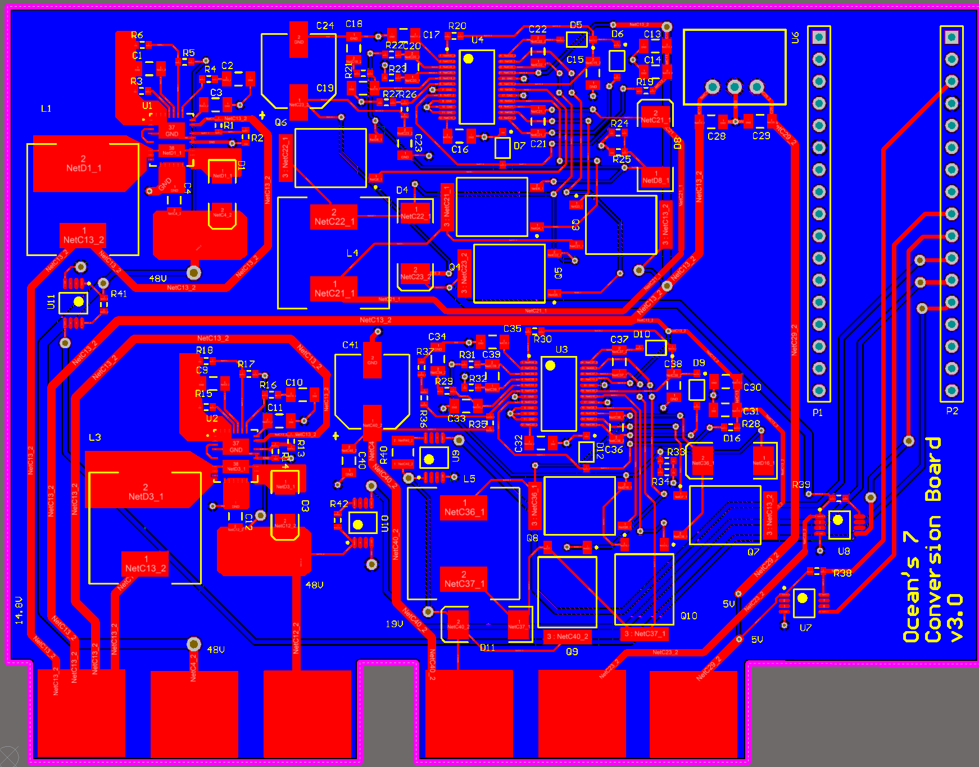

Figure 1.1 PCB layout of the Power Conversion Board

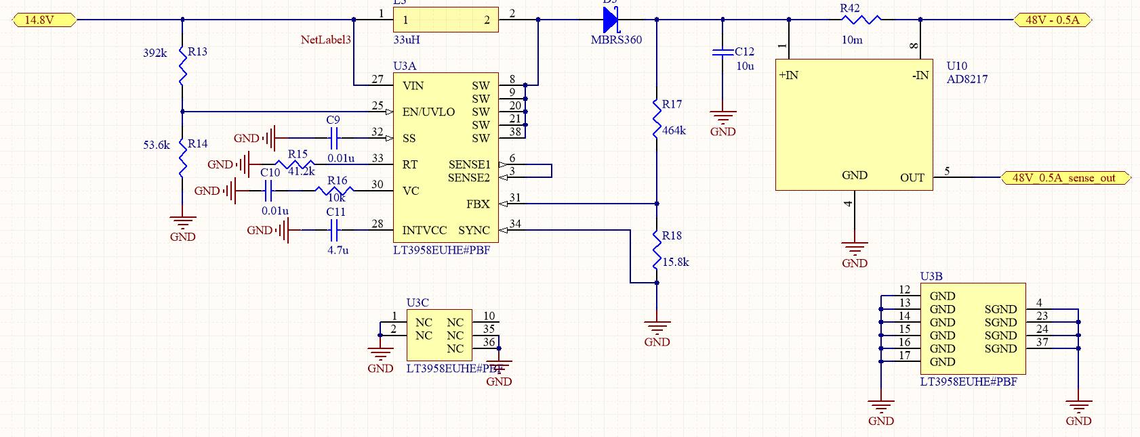

Figure 1.2 Schematic for 2 x 14.8V to 48V converters at 0.5 Amps.

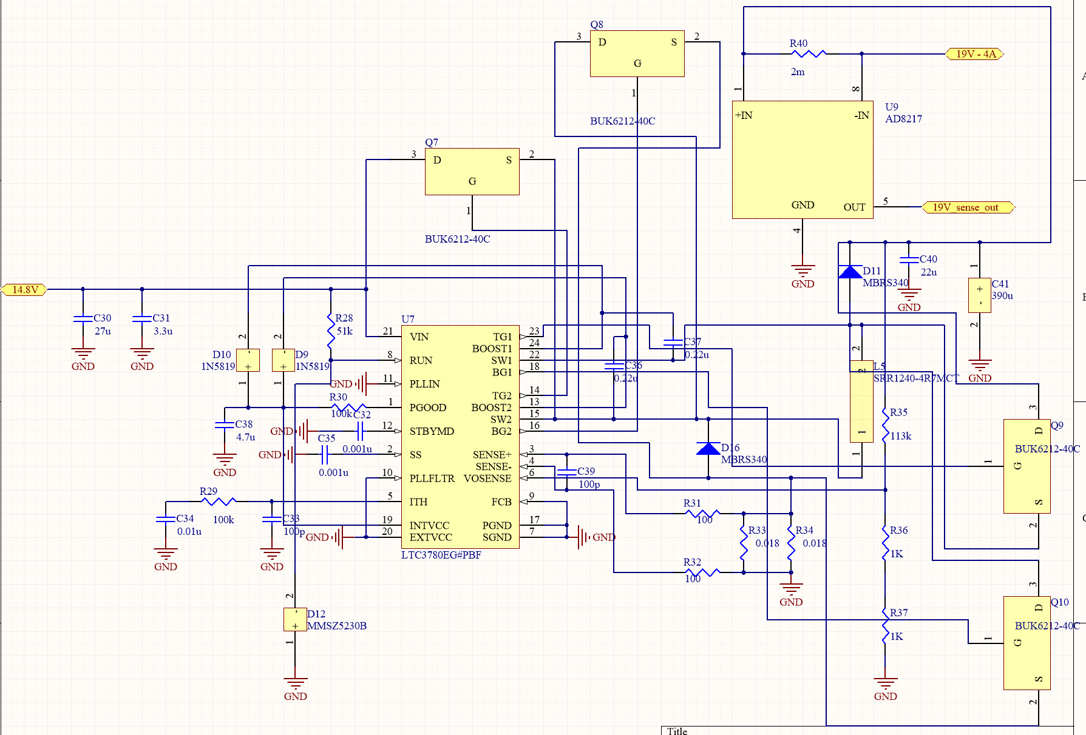

Figure 1.3 Schematic for 14.8V to 19V converter at 4 Amps.

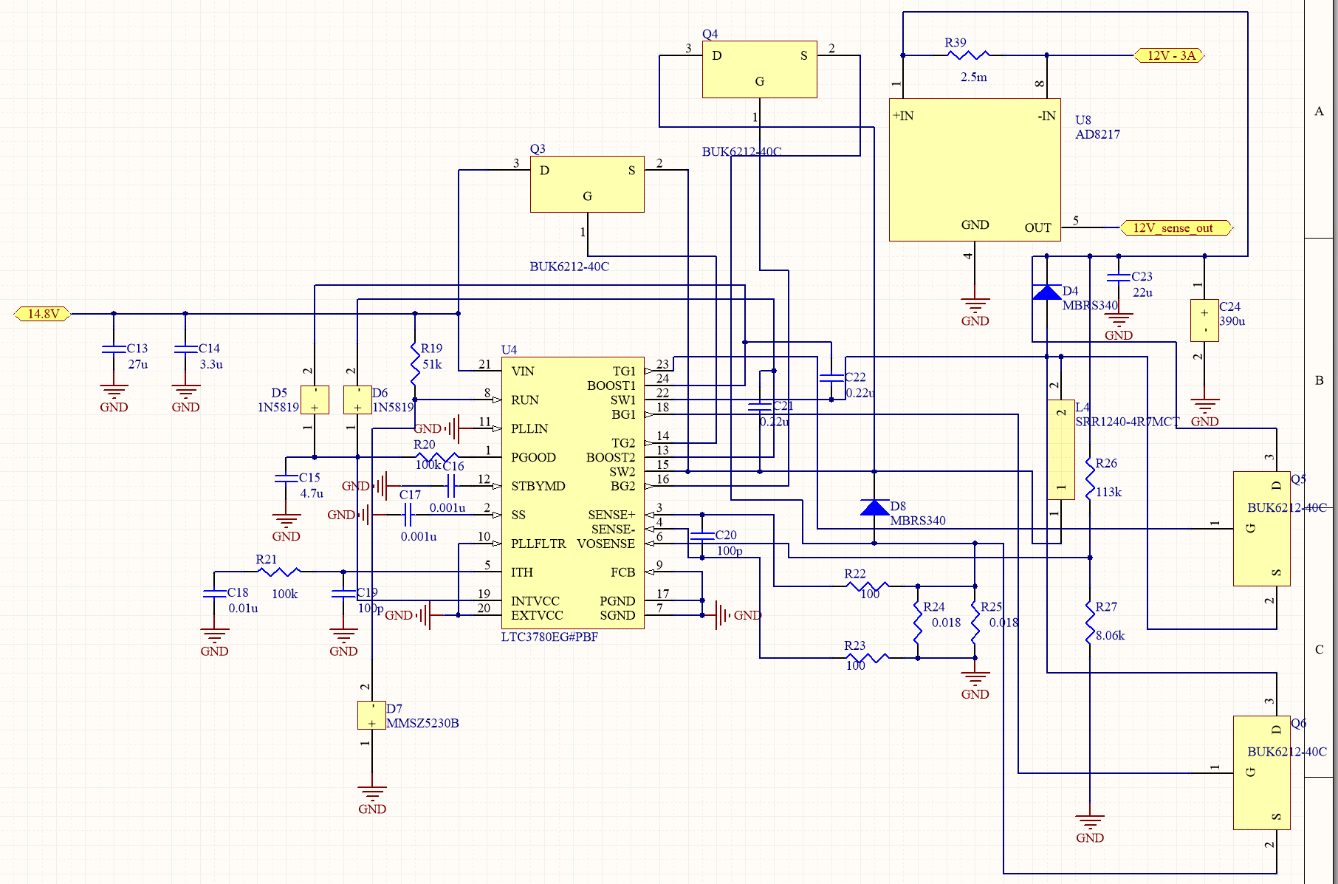Figure 1.4 Schematic for 14.8V to 12V converter at 3 Amps.

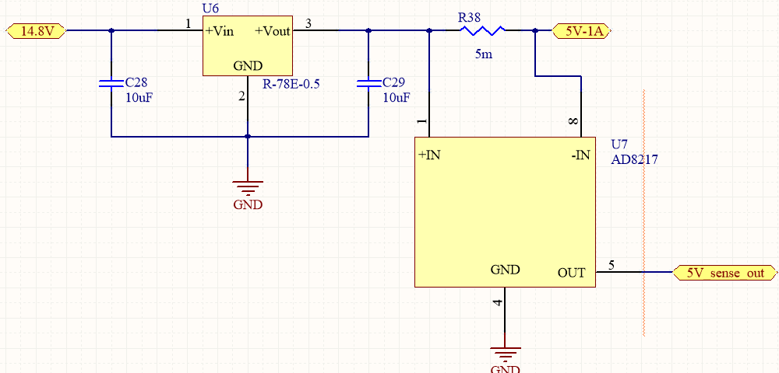

Figure 1.5 Schematic for 14.8V to 5V converter at 1 Amp.

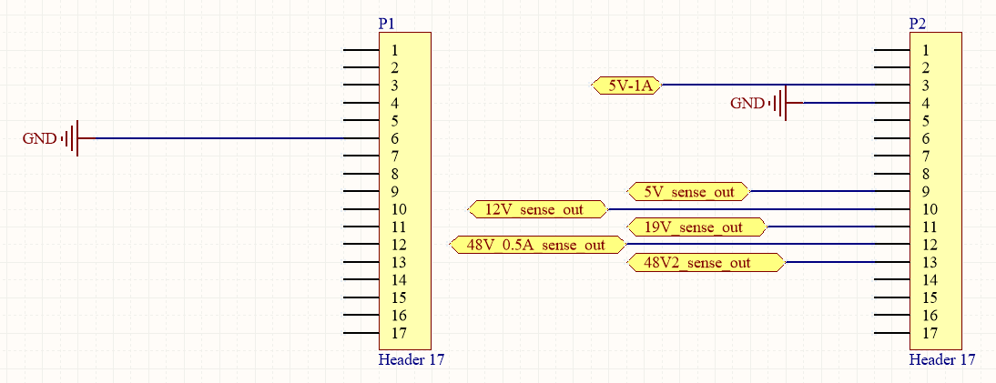

Figure 1.6 Schematic for Arduino Micro.

## 1.1 Proof of Concept Test Results

|  |  |  |
| --- | --- | --- |
| **Test** | **Success/Fail** | **Comments/Mitigation plans** |
| 14.8V to 5V converter | Success | The buck conversion circuit worked successfully as expected because of the simplicity of the switching regulator circuit. |
| 14.8V to 12V converter | Fail | Failed due to a manufacturing defect. One of the LTC3780 pin traces was running very close to a ground plane via, and they shorted together. We redesigned the 12V converter that is similar to the 19V converter but with different passive components. |
| 14.8V to 19V converter | Fail | We were able to get 19V, but was only able to draw 1 Amp of current. When we were drawing 4 Amps (the required current) the voltage dropped from 19V to 3V. To fix this we changed some components like inductors to let this circuit draw 4A. |
| 14.8V to 48V converter | Success | We had three identical versions of the 48V conversion circuit, and only one of them worked successfully. The reason behind the failure of the other two were soldering issues. The LT3958 has quad-flat no-leads (QFN) which makes it hard to solder without shorting some of the pins. We used the Voltera solder paste dropper to avoid soldering issues with these parts. |

## 1.2 Integration Test Results

|  |  |  |
| --- | --- | --- |
| **Test** | **Success/Fail** | **Comments/Mitigation plans** |
| 14.8V to 5V converter | Success | We were able to get the desired output voltage of 5V and output current of 1A. |
| 14.8V to 12V converter | Fail | We were able to get the desired output voltage of 12V however the output current capacity was insufficient. We couldn’t get the desired output current because the switching MOSFETs that we used were only rated for 8W, whereas they should be able to handle more than 36W. We used MOSFETs with higher power rating to get the required current. |
| 14.8V to 19V converter | Fail | We were able to get the desired output voltage of 19V however the output current capacity was insufficient. We couldn’t get the desired output current because the switching MOSFETs that we used were only rated for 8W, whereas they should be able to handle more than 76W. We used MOSFETs with higher power rating to get the required current. |
| 14.8V to 48V converter | Success | We were able to get an output voltage of 45V which is in the acceptable range for the desired output voltage and we were able to get the desired output current of 0.5A. |

## 1.3 Acceptance Test Results

|  |  |  |
| --- | --- | --- |
| **Test** | **Success/Fail** | **Comments/Mitigation plans** |
| 14.8V to 5V converter | Success | We were able to get the desired output voltage of 5V and output current of 1A. |
| 14.8V to 12V converter | Success | We were able to get the desired output voltage of 12V and output current of 3A. |
| 14.8V to 19V converter | Success | We were able to get the desired output voltage of 19V and output current of 4A. |
| 14.8V to 48V converter | Success | We were able to get the desired output voltage of 48V and output current of 0.5A. |